TK Use Case (MUNDAT)
Sirin MSc Thesis, use case #1, Trondheim Kommune (TK) use case (UC).
In DataPACT, SINTEF provide the tools and support, while the UC owners are responsible for building their own pipelines, however for this thesis work Sirin has built the pipeline using inLUMEN.

What kind of pipeline?
The compliance flow: receiving and validating a data-sharing request, finding and processing the relevant data, running the thesis checks, and supporting the sharing decision.
Goal: Represent the TK compliance flow: receive request → validate → find/process data → run checks → support sharing decision.
* see the image below
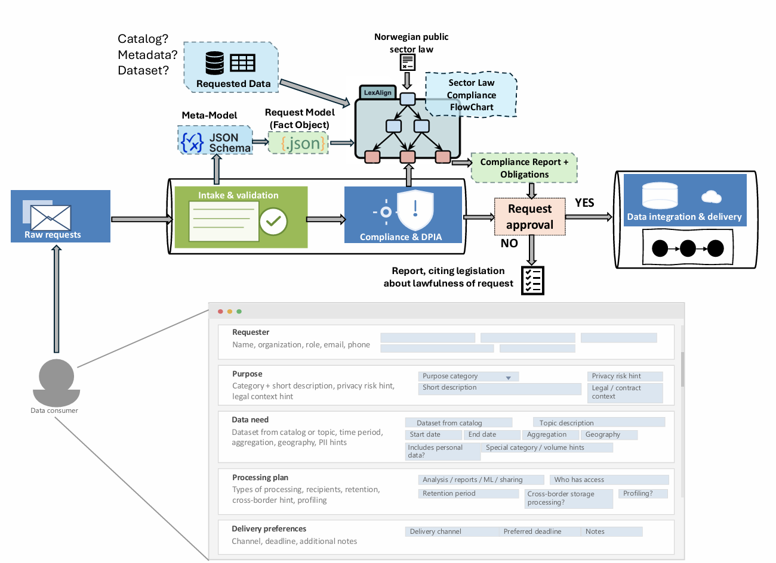

What is TK UC?  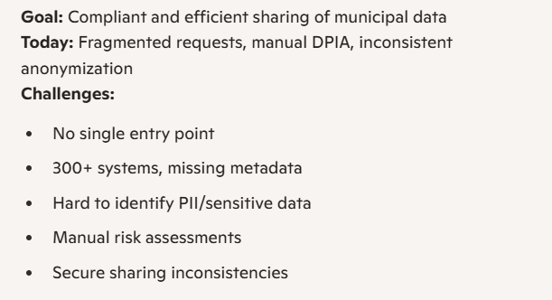 |  | What is InspecteR?  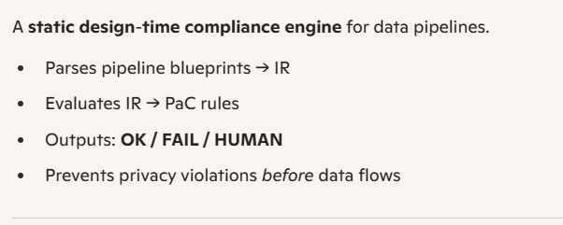  - IR – Intermediate Representation (universal graph model)  - PaC – Policy as Code (codified ruleset)  - Compliance Engine outputs OK/FAIL/HUMAN in machine-readable and actionable format with remedy suggestions
What is InspecteR trying to solve?  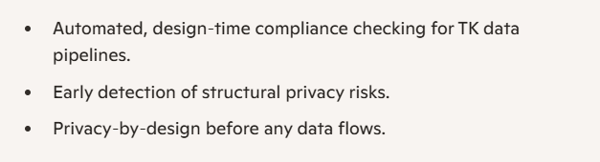  How InspecteR Detects Violations?  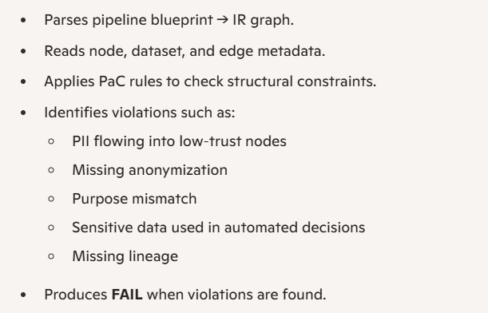 |  | How it works?  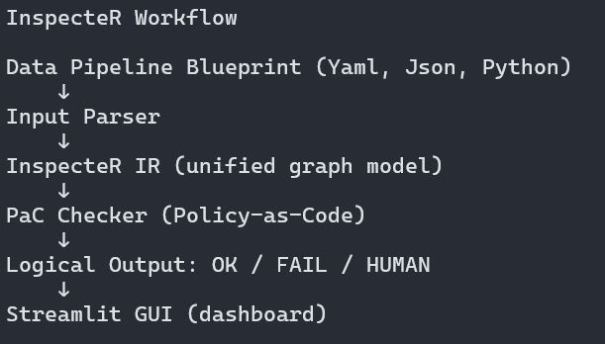
Core problems in TK UC  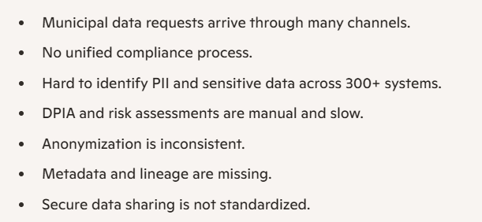  Why this matters?  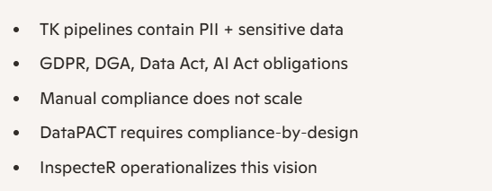 |  | TK Pipeline structure:  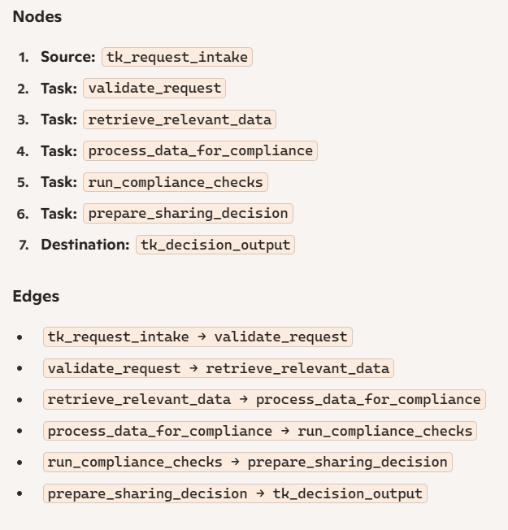
Prompt for inLUMEN’s LLM GUI  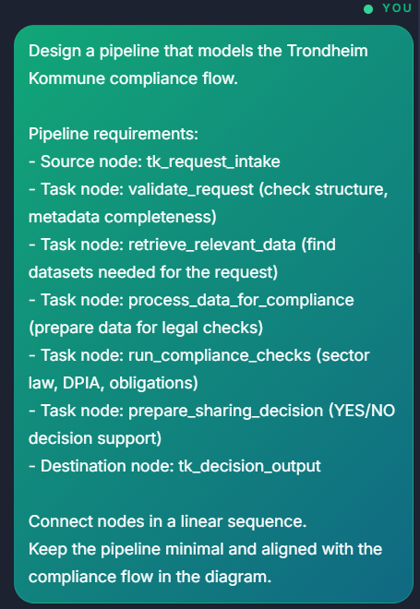 |  | 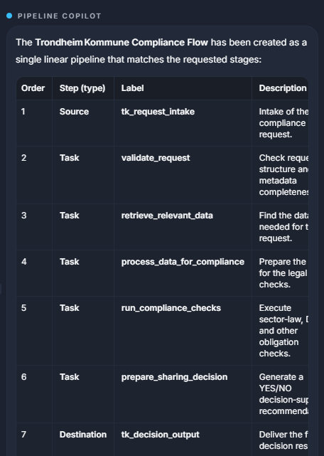
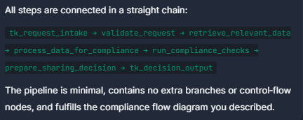

- SS image outputs from inLUMEN 07092026
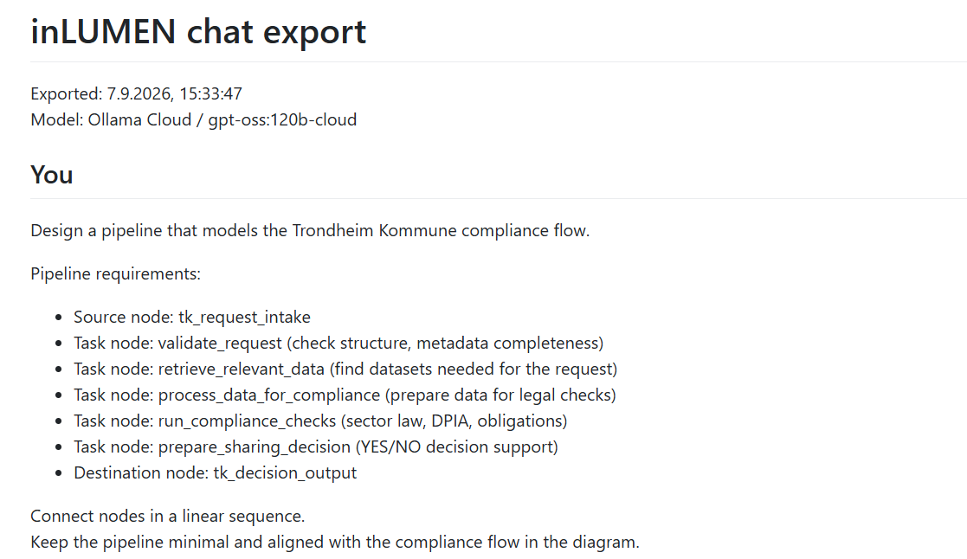

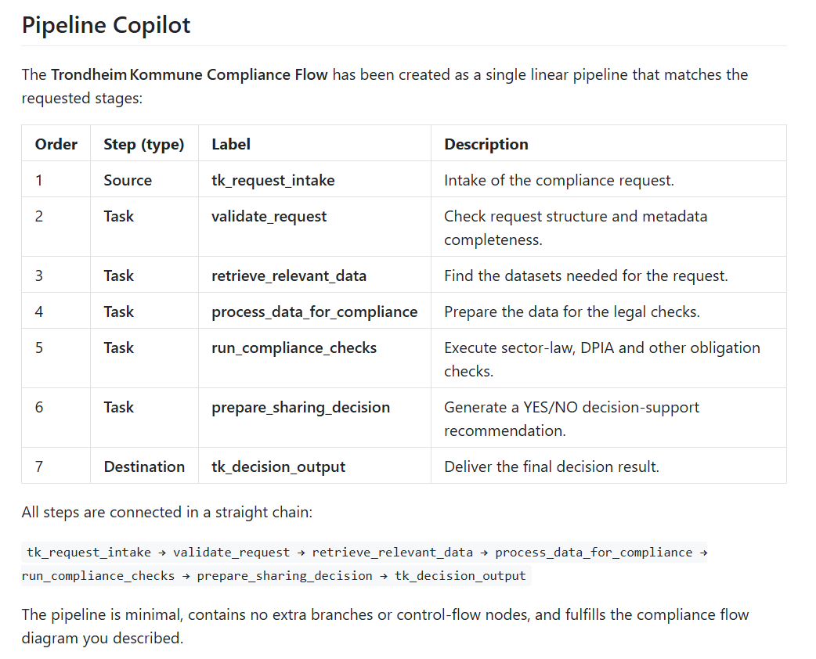

Result

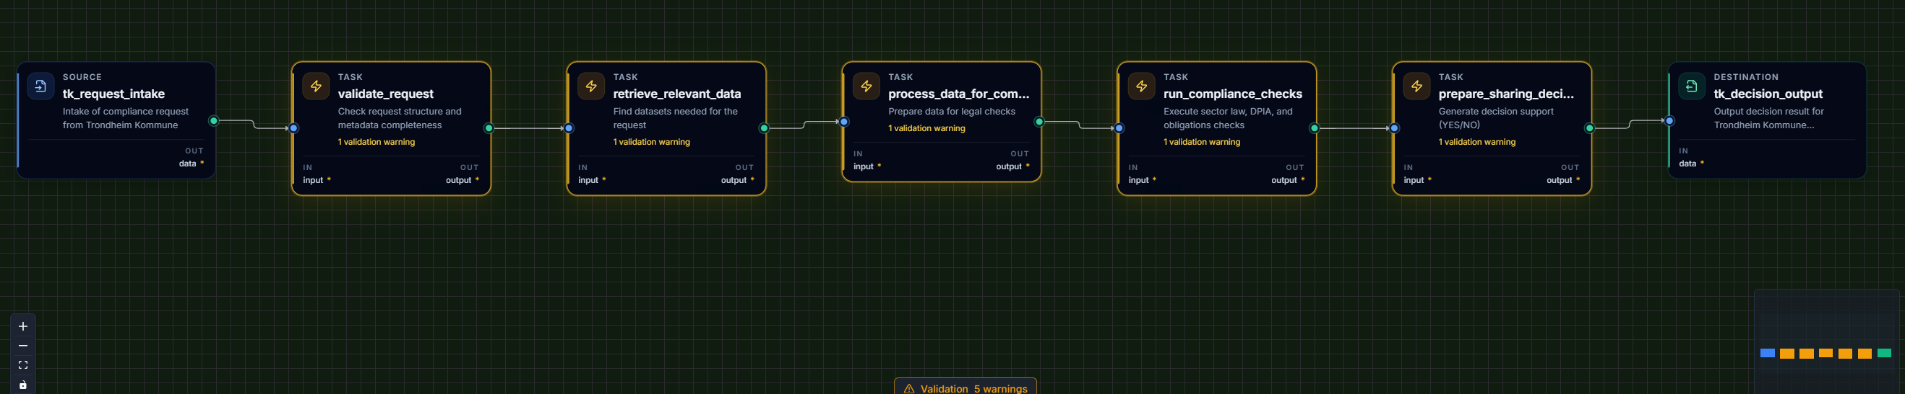


The TK pipeline design is completed in no time and it looks correct with the correct stages.
inLUMEN gives 5 warnings “No Task implementation is attached. Generate code or upload main.py.”
This means inLUMEN expects executable code for each Task node and we are not providing ny implementation code, so that’s why we get these warnings. But, the pipeline is valid and will be exported as a blueprint. This is quite normal for demos and use cases I believe. InspecteR will inspect static blueprints, not executable pipelines.
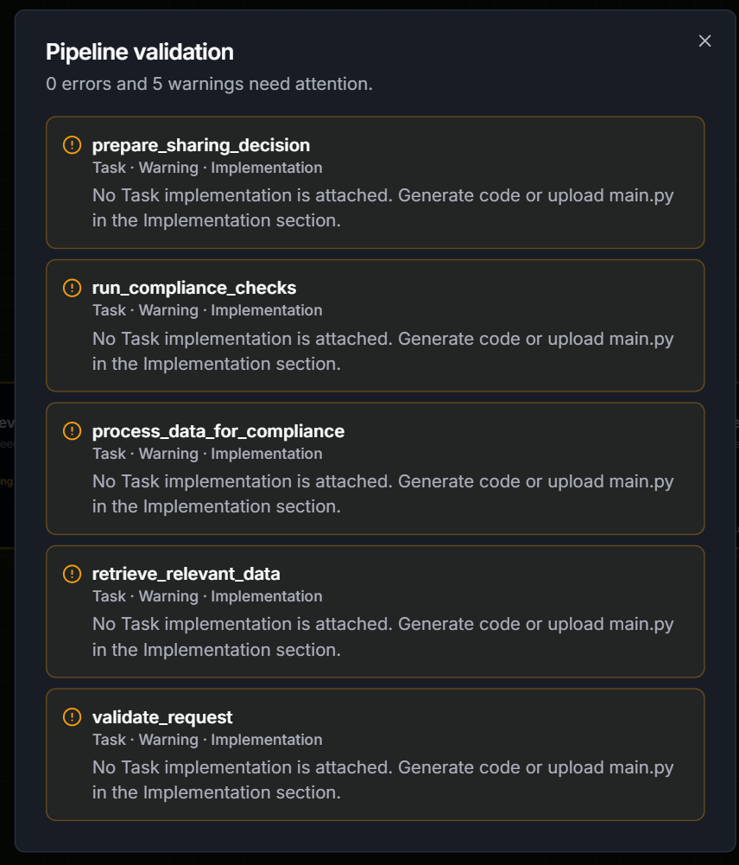

TK use case and pipeline design blueprint
“Goal: Represent the TK compliance flow: receive request → validate → find/process data → run checks → support sharing decision.”
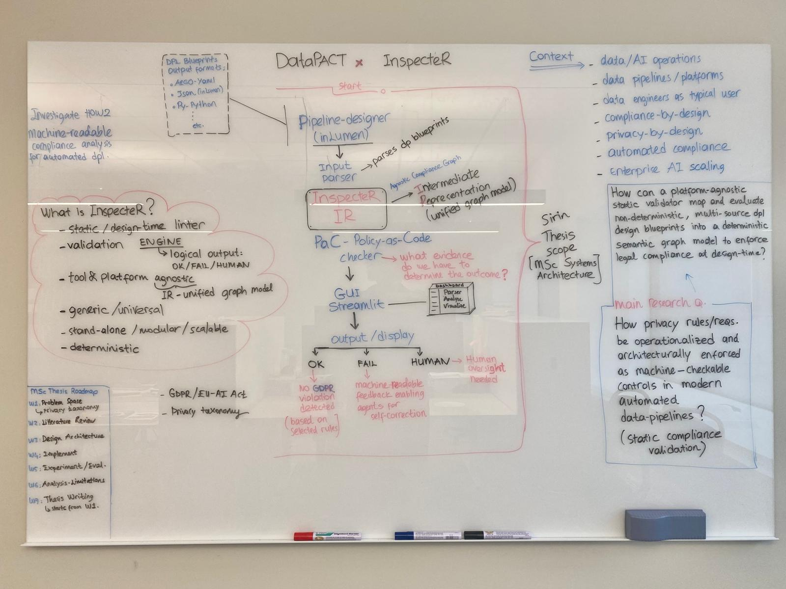
The Trondheim Kommune (TK) use case models a data-sharing compliance flow: a request comes in, is validated, relevant data is located and processed, specific checks are run, and the result supports a sharing decision. The pipeline is designed in inLUMEN, and exported as a static blueprint (no executable task code), which is exactly what InspecteR will analyse. “InspecteR will inspect static blueprints, not executable pipelines.”
So for TK UC, your “AI system” is essentially the data pipeline blueprint + its compliance stages, not runtime behaviour.

InspecteR’s role (policy-as-code compliance engine)
InspecteR is:
- Static/design-time validator: runs on pipeline blueprints (JSON/YAML/etc.).
- Intermediate Representation (IR): unified graph model of the pipeline (nodes, edges, data flows, controls).
- Policy-as-Code engine: evaluates IR against codified rules (GDPR, EU AI Act, privacy taxonomy).
- Output: OK (no violation), FAIL (machine-readable violation + remedy), HUMAN (needs human oversight).

For TK UC, InspecteR answers:
“Given this pipeline blueprint, is the data-sharing decision flow compliant with EU AI Act, and where do we need human review?”

Minimal EU AI Act mapping for TK UC (no overload)
For this specific TK pipeline, you can start with a small, focused subset of the Act:
- Scope and classification
  - Is this an AI system? If the pipeline uses ML/LLM components to infer or decide (e.g., automated risk scoring, automated decision support), treat it as an AI system under the Act.
  - Is it high-risk? TK UC is about data sharing, not credit scoring or hiring, so likely non-high-risk, but it may still affect fundamental rights (privacy, access to services). For now: classify TK UC as non-high-risk decision support with strong privacy impact.
- Core obligations relevant to TK UC Even for non-high-risk, you can encode:
  - Transparency: pipeline must clearly mark where AI is used in the decision flow and what it does.
  - Human oversight: final sharing decision must have a human override (HUMAN path in InspecteR).
  - Data governance: data used in the pipeline must be:
    - Lawful (GDPR legal basis).
    - Minimised (only necessary data for the request).
    - Protected (no prohibited biometric categorisation, no social scoring).
  - Logging and traceability: the pipeline must log:
    - Incoming request.
    - Data sources accessed.
    - Checks performed.
    - Final decision and who/what made it.
- Prohibited practices (Art. 5) – keep it simple For TK UC, encode hard-fail rules for:
  - Social scoring: pipeline must not compute cross-context “scores” about citizens.
  - Biometric categorisation of sensitive attributes: pipeline must not infer political opinions, religion, etc. from biometric data.
  - Manipulative exploitation of vulnerabilities: pipeline must not target children or vulnerable groups with manipulative AI decisions.
This is enough for a first thesis iteration: you don’t need the full Act yet, just a thin slice that is clearly relevant to TK UC.

How to express this as policy-as-code in InspecteR
Assume inLUMEN exports a PipelineBlueprint (JSON/YAML) and you convert it to IR (graph). Your rules then run on IR.

IR essentials for TK UC
Your IR should at least capture:
- Nodes: request intake, validation, data retrieval, processing, checks, decision.
- Edges: data flows between nodes.
- Data: categories (personal, special categories, biometric), sources (TK systems).
- Controls: logging, human review step, transparency notices.
- AI components: any ML/LLM agents used in validation or decision.

Example rule patterns (conceptual, not full code)
- Scope: is AI used?
text
RULE: ai_system_present
IF IR contains node.type == "LLM" OR node.type == "ML_model"
THEN mark pipeline.ai_system = true
- Human oversight required for sharing decision
text
RULE: require_human_oversight_for_sharing
IF node.type == "decision" AND node.output == "share_data"
AND pipeline.ai_system == true
THEN require a connected node.type == "human_review"
ELSE result = FAIL("No human oversight for data sharing decision")
- Data minimisation
text
RULE: data_minimisation
IF node.type == "data_retrieval"
AND node.data_categories includes fields not tagged as "needed_for_request"
THEN result = FAIL("Data minimisation violated")
- Prohibited social scoring
text
RULE: prohibit_social_scoring
IF IR contains node.feature == "social_score"
THEN result = FAIL("Prohibited social scoring practice")

InspecteR then aggregates rule results into OK / FAIL / HUMAN for the TK pipeline.

TK UC

Problem space understanding, classification, abstraction, justification

1.1 Describe the concrete TK problem
Very short, in your words:
- Context: SINTEF/DataPACT, Trondheim Kommune data-sharing requests.
- Pipeline: request → validate → find/process data → run checks → support sharing decision.
- Design tool: inLUMEN, exporting static pipeline blueprints.
- Validator: InspecteR, static/design-time checker.
This is your primary scenario.

1.2 Identify actors, artefacts, and risks
- Actors:
  - TK as data controller.
  - Data engineers / platform team (pipeline designers).
  - Citizens whose data may be shared.
- Artefacts:
  - Pipeline blueprint (inLUMEN output).
  - Data sources (TK systems).
  - Compliance rules (GDPR + small slice of EU AI Act).
- Risks:
  - Unlawful data sharing.
  - Missing human oversight.
  - Lack of logging/traceability.
  - Use of AI components without clear controls.
This gives you the problem space: “design-time validation of data-sharing pipelines to avoid privacy and AI-related violations”.

1.3 Classification and abstraction
- Classification:
  - TK pipeline = non-high-risk AI-related data-sharing flow with strong privacy impact.
  - It may use AI components (LLMs, checks), but it’s not credit scoring, hiring, etc.
- Abstraction:
  - Any modern data platform has:
    - Stages: intake, validation, data retrieval, processing, decision.
    - Controls: logging, human review, transparency.
  - You abstract TK UC into a generic pipeline model with these stages and controls.
- Justification:
  - DataPACT’s goal is compliance-by-design.
  - Static validation of blueprints fits perfectly: you catch violations before data flows.
  - InspecteR is your architectural answer: a platform-agnostic linter that enforces legal rules at design-time.
That’s enough for a clear “problem space” chapter.

2. Simple PoC of InspecteR (without IR) using a small portion of EU AI Act
We keep this tiny and concrete.

2.1 Choose a minimal slice of the EU AI Act
For TK UC, you can start with just:
- Prohibited practices (Art. 5):
  - No social scoring.
  - No biometric categorisation of sensitive attributes.
- Basic safeguards (non-high-risk, but sensible):
  - Human oversight for data-sharing decisions.
  - Logging of request, data access, and decision.
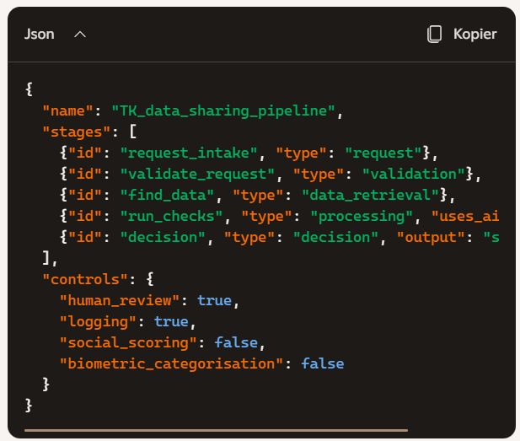
That’s it—4–5 rules.

2.2 Represent the TK pipeline in a very simple JSON
Example (you can adapt to inLUMEN’s export later):
json
{
"name": "TK_data_sharing_pipeline",
"stages": [
{"id": "request_intake", "type": "request"},
{"id": "validate_request", "type": "validation"},
{"id": "find_data", "type": "data_retrieval"},
{"id": "run_checks", "type": "processing", "uses_ai": true},
{"id": "decision", "type": "decision", "output": "share_or_not"}
],
"controls": {
"human_review": true,
"logging": true,
"social_scoring": false,
"biometric_categorisation": false
}
}
This is your blueprint for the PoC.

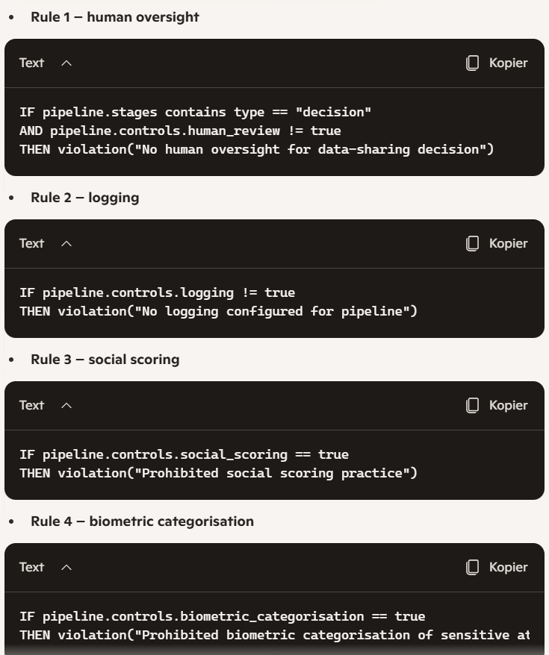
2.3 Implement a tiny InspecteR checker (pseudo-logic)
You can do this in Python, Rego, or any language—logic like:

- Rule 1 – human oversight
text
IF pipeline.stages contains type == "decision"
AND pipeline.controls.human_review != true
THEN violation("No human oversight for data-sharing decision")
- Rule 2 – logging
text
IF pipeline.controls.logging != true
THEN violation("No logging configured for pipeline")
- Rule 3 – social scoring
text
IF pipeline.controls.social_scoring == true
THEN violation("Prohibited social scoring practice")
- Rule 4 – biometric categorisation
text
IF pipeline.controls.biometric_categorisation == true
THEN violation("Prohibited biometric categorisation of sensitive attributes")

Then:
- If no violations: output OK.
- If violations but fixable: output FAIL with messages.
- If something is ambiguous (e.g., missing fields): output HUMAN.
This is a PoC InspecteR without IR: it just reads one JSON, runs a handful of rules, and prints OK/FAIL/HUMAN.

Concrete, light-weight next steps
- Freeze a simple TK PipelineBlueprint schema Just enough fields to represent:
  - Stages: request → validate → find/process data → checks → decision.
  - Data categories and sources.
  - AI components (if any).
  - Human review step.
- Implement IR + 5–10 core rules Start with:
  - ai_system_present
  - require_human_oversight_for_sharing
  - data_minimisation
  - logging_present_for_each_stage
  - prohibit_social_scoring / prohibit_biometric_categorisation
- Run InspecteR on the TK blueprint Show:
  - How a valid TK pipeline gets OK or HUMAN.
  - How a deliberately “bad” pipeline (e.g., no human review, extra data pulled) gets FAIL.
- Use this as your first “policy-as-code for EU AI Act” chapter You can later expand to more articles and more complex use cases, but this gives you a clear, implementable starting point that fits your thesis scope and TK UC.

Mapping EU AI Act to InspecteR
EU AI Act for AI Pipelines & Pipeline Designers
Subset of the EU AI Act that matters for AI-driven data pipelines and pipeline-design tools such as inLUMEN, grounded in the content of the Regulation in your open tab. Citations refer to the Regulation text in the tab.
Most Relevant Portions of the EU AI Act for AI Pipelines & Pipeline Designers
AI pipelines and pipeline-design tools (like inLUMEN) are not physical products. They are AI systems or AI-enabled components that perform inference, decision-support, or automated processing. The relevant parts of the Act are those that regulate:
- what counts as an AI system
- what is prohibited
- what obligations apply to non-high-risk and high-risk systems
- what documentation, transparency, oversight, and data governance must exist
- how pipeline operators (providers/deployers) must behave
Everything below is directly tied to pipeline design and static blueprint validation.

1. Definition of an AI System (Mandatory for Pipelines)
The Act defines AI systems by their capability to infer — generating predictions, content, recommendations, or decisions. This applies directly to any pipeline stage using ML/LLM/agents.
“A key characteristic of AI systems is their capability to infer… outputs such as predictions, content, recommendations, or decisions…”
This definition is essential because it determines whether a pipeline component falls under the Act.
2. Prohibited AI Practices (Always Relevant for Pipeline Validation)
These prohibitions apply to all AI systems, regardless of risk level. Pipeline blueprints must never include components performing:
2.1 Manipulative or exploitative AI systems
“…AI systems with the objective or effect of materially distorting human behaviour… causing significant harm…”
2.2 Biometric categorisation inferring sensitive attributes
“…deduce or infer political opinions, religious beliefs, race, sex life or sexual orientation… should be prohibited.”
2.3 Social scoring
“…AI systems providing social scoring… should therefore be prohibited.”
These three prohibitions are the most important and easiest to encode as policy-as-code rules for a pipeline validator.
3. Transparency & Human Oversight (Critical for Pipeline Decision Nodes)
Even non-high-risk systems must ensure:
- humans understand when AI is used
- humans can override AI decisions
- AI outputs are traceable and explainable
“Human agency and oversight means that AI systems… can be appropriately controlled and overseen by humans.”
This maps directly to pipeline decision nodes: any pipeline stage producing a decision affecting people must include human review.
4. Data Governance & Privacy Alignment (Mandatory for All Pipelines)
The Act explicitly preserves GDPR obligations:
“This Regulation does not seek to affect the application of existing Union law governing the processing of personal data…”
For pipeline validation, this means:
- lawful basis must be declared
- special categories must be controlled
- biometric data must be restricted
- data minimisation must be enforced
- logging and traceability must exist
These are static properties that can be checked in pipeline blueprints.
5. High-Risk AI System Requirements (Relevant Only If Pipeline Purpose Falls Under Annex III)
Most data-processing pipelines (including TK UC) are not high-risk. But if a pipeline performs tasks such as:
- biometric identification
- credit scoring
- access to essential services
- employment decisions
- law enforcement analysis
then the following obligations apply:
- risk management
- data quality and bias controls
- technical documentation
- logging
- human oversight
- robustness and cybersecurity
These obligations are structural and can be encoded as static rules.
6. Provider & Deployer Obligations (Directly Relevant to Pipeline Designers)
Pipeline designers and operators fall under:
- Providers → creators of the pipeline blueprint
- Deployers → entities using the pipeline in production
The Act applies to both:
“…rules established by this Regulation should apply to providers… and to deployers of AI systems…”
This means pipeline blueprints must include:
- declared purpose
- declared AI components
- declared controls
- declared data categories
- declared oversight mechanisms
All of these can be validated statically.
7. Risk-Based Approach (Guides How InspecteR Should Classify Pipelines)
The Act uses a three-tier model:
“…prohibit certain unacceptable AI practices, lay down requirements for high-risk AI systems, and lay down transparency obligations for certain AI systems.”
InspecteR can mirror this:
- Tier 1: Prohibited → FAIL
- Tier 2: High-risk obligations → FAIL/HUMAN if missing
- Tier 3: Transparency obligations → OK/HUMAN
This is the simplest and most defensible mapping.
Summary: The Most Relevant Portions for AI Pipelines & inLUMEN
Mandatory for all pipelines
- Definition of AI system
- Prohibited practices (manipulation, biometric categorisation, social scoring)
- Transparency & human oversight
- Data governance & GDPR alignment
- Provider/deployer obligations
- Risk-based classification logic
Relevant only if pipeline is high-risk
- High-risk obligations (risk management, documentation, oversight, robustness)
These sections are the exact subset needed to build a minimal, defensible, academically sound PoC for InspecteR.
If desired, the next step can be: mapping these sections into a minimal policy-as-code ruleset for your PoC.
I think it would be wise if I can build a machine-readable and visualizeable taxonomy, and connect it to the EU AI Act
Se mine tanker
Taxonomy as machine-readable, visualisable structure
1. Representation model
- Entities:
  - Domain, Dimension, SubDimension, AtomicElement, Constraint.
- Fields per node:
  - id (stable identifier)
  - label (human-readable name)
  - type (e.g. Dimension, AtomicElement, Constraint)
  - parent_id (hierarchical link)
  - attributes (e.g. data_category, ai_component, control_type)
Stored as JSON/YAML and visualised as a graph (nodes + edges) or tree.
Mapping to EU AI Act
2. Article-linked constraints
Each Constraint node carries:
- ai_act_article (e.g. "Art.5")
- ai_act_recital (optional, e.g. "Recital 33")
- severity (prohibited, required, recommended)
- applicability (all_ai_systems, high_risk_only, gpai_only)
Examples:
- Constraint: ProhibitSocialScoring
  - parent_id: Risks.AI
  - ai_act_article: Art.5
  - severity: prohibited
- Constraint: ProhibitBiometricCategorisationSensitiveAttributes
  - parent_id: Risks.AI
  - ai_act_article: Art.5
  - severity: prohibited
- Constraint: RequireHumanOversightForDecisionNodes
  - parent_id: Controls.HumanOversight
  - ai_act_article: general obligations + recitals on human agency
  - severity: required
Connection to pipelines and inLUMEN
3. Binding taxonomy to pipeline blueprints
- Each pipeline node (from inLUMEN or other tools) is annotated with taxonomy IDs:
  - data_category_id → e.g. AtomicElement.PersonalData.SpecialCategory
  - component_type_id → e.g. AtomicElement.AIComponent.LLM
  - control_ids → e.g. Controls.Logging, Controls.HumanOversight
- InspecteR evaluates Constraints against these annotations:
  - If pipeline contains AtomicElement.SocialScore → violates Constraint.ProhibitSocialScoring.
  - If decision node lacks Controls.HumanOversight → violates Constraint.RequireHumanOversightForDecisionNodes.
Minimal PoC slice
4. Initial EU AI Act subset for taxonomy-linked rules
- Constraint.ProhibitSocialScoring (Art. 5).
- Constraint.ProhibitBiometricCategorisationSensitiveAttributes (Art. 5).
- Constraint.RequireHumanOversightForDecisionNodes (recitals on human agency/oversight).
- Constraint.RequireLoggingForPipelineStages (traceability/record-keeping recitals).
This subset is sufficient for a first machine-readable, visualisable taxonomy and a working PoC of InspecteR.

